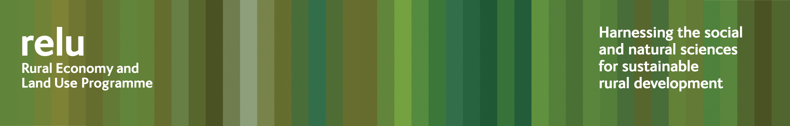

PRESS RELEASE for immediate release

23 June 2009

Is regional land use planning the key to regeneration?

Regional land use planning could be key to the regeneration of rural and urban areas, according to a new policy and practice note published by the UK Research Councils’ Rural Economy and Land Use Programme.

Research being carried out within the programme suggests that the new strategic plans that regional development agencies will be required to produce over the next two years will provide an opportunity to realise untapped potential for rural land.

This could include a major contribution to energy generation, climate change adaptation and a low carbon future.

Relu’s policy and practice note no 8 “Regional rural land use: a time for fresh thinking?” may be downloaded at http://www.relu.ac.uk/news/policy%20and%20practice%20notes/Rowe%20PP8%20final.pdf or hard copies obtained from relu@ncl.ac.uk.

Notes for editors:

1 The Rural Economy and Land Use Programme is an interdisciplinary collaboration between the Economic and Social Research Council (ESRC), the Biotechnology and Biological Sciences Research Council (BBSRC) and the Natural Environment Research Council (NERC), with additional funding provided by the Scottish Government and the Department for Environment, Food and Rural Affairs. See www.relu.ac.uk for more information about the Relu programme.

- For more information contact Anne Liddon, Science Communications Manager, tel 0191 222 6903 email anne.liddon@ncl.ac.uk.

Ends

